**Programming Assignment**

You will write a pet store application.

The pet store application is composed of 2 components:

* Pet Store Service component exposing Pet Store Operations as a rest API / jSON. The service has to be implemented in java language using spring boot. The interface is specified in section 1. Interface. You can choose the underlying data storage you want.
* Pet Store Front End component consuming the rest API and enabling user interaction with the Pet Store. This component has to be implemented in angularJS. You can show your creativity by designing an amazing UI.

Your solution need to work correctly locally with a reasonable responsiveness. The application has to follow a proper delivery cycle in an automated fashion: local build, local test, local deployment.

It would be nice to have:

A – Component deployed in bluemix public cloud (Paas)

B – Have authentication implemented

C – Have authorization implemented (user A can find/view only, user B can Add/find/view/delete)

1. **Interface**

You will find the description of the rest API to be implemented on <http://petstore.swagger.io/>.

You just need to implement the 3 following operations:

* Add a new pet to the store
* Deletes a pet
* Find pet by ID

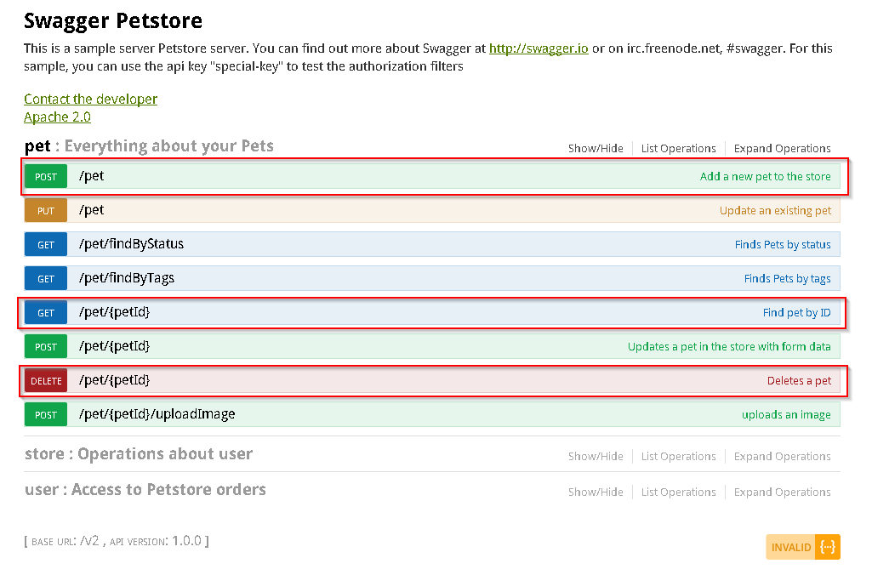

1. **Assessment**

The following will be executed on your own laptop, could you please bring it with you the day of the interview

* You will be asked to perform a demonstration of your application for the 3 operations through the front-end and through the rest API.
* You will be asked to do a code change of both components and re-run the full delivery cycle and do the demonstration again